**TerraWeek Day 7 -** **Advanced Terraform Topics**

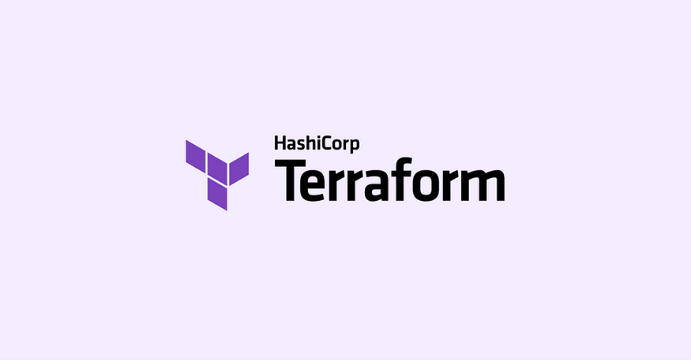

Welcome to the advanced TerraWeek challenge! In this phase, we will dive into advanced topics that will enhance your Terraform skills. Let's explore exciting concepts such as workspaces, remote execution, collaboration, best practices, and additional features to take your Terraform knowledge to the next level.

**Task 1: Workspaces, Remote Execution, and Collaboration**

* 1. **Dive into the concepts of Terraform workspaces and understand how they can be utilized to manage multiple environments.**

Terraform Workspaces: Terraform workspaces are a powerful feature that allows you to manage multiple environments or deployments within a single Terraform configuration. Workspaces enable you to maintain separate state files for different environments, such as development, staging, and production, while using the same infrastructure code.

By creating and switching between workspaces, you can modify and apply changes to specific environments without affecting others. This separation provides isolation and allows you to make environment-specific configurations, such as different variable values or resource settings.

Workspaces can be created using the terraform workspace new command and switched using terraform workspace select. Each workspace maintains its own state file, which tracks the resources and their configurations for that specific environment. This way, you can easily manage and track changes across different environments using Terraform commands like terraform plan, terraform apply, and terraform destroy.

**1.2 Explore remote execution options such as using remote backends (e.g., AWS S3, Azure Storage Account, or HashiCorp Consul) and understand the benefits they offer.**

Using AWS S3 as a remote backend in Terraform involves configuring the backend block in your Terraform configuration file. Here's an example of how to set up an AWS S3 remote backend:

terraform {

backend "s3" {

bucket = "your-s3-bucket-name"

key = "your-terraform-state-key"

region = "your-aws-region"

}

}

In this example, you need to replace **"your-s3-bucket-name"** with the name of your S3 bucket where you want to store the Terraform state file. Similarly, replace **"your-terraform-state-key"** with a unique key name for your state file, and **"your-aws-region"** with the AWS region where your S3 bucket is located.

By configuring the S3 backend, terraform will automatically store and retrieve the state file from the specified S3 bucket. This enables remote collaboration, versioning, and state locking when working with Terraform across multiple team members or environments. It also ensures that your state file is stored securely and reliably in AWS S3, providing durability and scalability for your infrastructure deployments.

Using AWS S3 as a remote backend in Terraform provides the following benefits:

1. **Scalability and Durability**: AWS S3 is highly scalable and offers durable storage, ensuring the safe and reliable storage of your Terraform state files.
2. **Collaboration and Locking**: S3 remote backends support state locking, preventing concurrent modifications and enabling seamless collaboration among team members.
3. **Secure Access Control**: With AWS IAM, you can configure fine-grained access control for the S3 bucket, ensuring only authorized users can access and modify the Terraform state.
4. **Versioning and Backup**: S3 supports versioning, allowing you to store and retrieve previous versions of your Terraform state. This feature acts as a backup mechanism and facilitates rollbacks if necessary.
5. **Integration with AWS Services**: Leveraging S3 as a remote backend integrates well with other AWS services, enabling you to incorporate Terraform deployments into your broader AWS infrastructure management.

**Task 2: Terraform Best Practices**

**2.1 Familiarize yourself with Terraform best practices, including code organization, module usage, and naming conventions.**

**Code Organization:** Organize your Terraform code into directories and modules to promote reusability and maintainability. Follow a logical structure based on environments, components, or functionality.

**Module Usage:** Create reusable modules to encapsulate related resources and configuration logic. Define clear module interfaces with input variables and output values.

**Naming Conventions:** Use descriptive and consistent names for resources, modules, variables, and outputs. Avoid hardcoding values and leverage variables for flexibility.

**Documentation:** Include comments and documentation in your code to provide context and explain the purpose of resources and configurations.

**State Management:** Store your Terraform state files securely, preferably in a remote backend like AWS S3, to enable collaboration and state locking.

* 1. **Explore version control systems (e.g., Git) and learn how to effectively manage your Terraform codebase.**

**Initialize a Git repository:** Set up a Git repository to track changes in your Terraform codebase.

**Commit and manage changes:** Regularly commit your changes, create branches for new features or fixes, and merge them back into the main branch.

**Use Git workflows:** Adopt popular Git workflows like GitFlow or feature branches to facilitate collaboration and code review processes.

**Leverage Git tags:** Use Git tags to mark important milestones or versions of your Terraform code.

**2.3 Understand how to integrate Terraform with CI/CD pipelines and implement automated testing, validation, and deployment strategies.**

**Continuous Integration (CI):** Integrate Terraform with your CI pipeline to automatically build, validate, and test your infrastructure code.

**Automated Testing:** Set up automated tests to validate your Terraform configurations. Use tools like Terratest or InSpec for infrastructure testing.

**Continuous Deployment (CD):** Automate the deployment of your Terraform code to various environments using CD pipelines. Use tools like Jenkins, GitLab CI/CD, or AWS CodePipeline.

**Infrastructure as Code (IaC) Validation:** Incorporate linting tools like TFLint or static analysis tools like Checkov to ensure adherence to best practices and security standards.

**Task 3: Exploring Additional Features**

**3.1 Dive deeper into Terraform Cloud or Terraform Enterprise and understand how they provide enhanced collaboration, infrastructure management, and workflow automation capabilities.**

Terraform Cloud and Terraform Enterprise are powerful platforms that provide enhanced collaboration, infrastructure management, and workflow automation capabilities. Let's dive deeper into these aspects:

Enhanced Collaboration:

* Centralized Collaboration: Terraform Cloud and Terraform Enterprise serve as centralized platforms where teams can collaborate on infrastructure provisioning and management. They provide shared workspaces where team members can work together, share code, and coordinate changes.
* Concurrent Development: Multiple team members can work simultaneously on the same infrastructure, thanks to features like workspace locking and version control integration. This enables concurrent development and reduces conflicts.
* Commenting and Feedback: These platforms offer commenting and feedback features, allowing team members to discuss infrastructure changes, propose improvements, and address concerns directly within the platform. This improves communication and collaboration among team members.

Infrastructure Management:

* Remote State Management: Terraform Cloud and Terraform Enterprise store the Terraform state remotely, providing a centralized and secure location for managing state files. This eliminates the need for manual state file management and enables seamless collaboration on infrastructure.
* Workspace Management: They provide robust workspace management capabilities, allowing you to organize and manage your infrastructure configurations efficiently. Workspaces can be created for different environments, projects, or teams, enabling effective infrastructure management at scale.
* Policy Enforcement: These platforms support policy enforcement to ensure compliance and security. Policies can be defined to validate infrastructure configurations, enforce standards, and prevent non-compliant changes. This helps maintain a consistent and secure infrastructure environment.

Workflow Automation:

* CI/CD Integration: Terraform Cloud and Terraform Enterprise seamlessly integrate with popular CI/CD tools, allowing you to incorporate Terraform into your automated workflows. You can trigger Terraform runs as part of your CI/CD pipelines, enabling automated infrastructure deployments and updates.
* Sentinel Policy as Code: Both platforms support Sentinel, which is a policy-as-code framework. With Sentinel, you can define and enforce custom policies to ensure compliance, security, and governance in your infrastructure deployments. This helps automate policy enforcement and maintain a secure infrastructure environment.
* Notification and Monitoring: Terraform Cloud and Terraform Enterprise provide notification and monitoring capabilities. You can receive alerts on infrastructure changes, track the status of Terraform runs and deployments, and monitor the overall health of your infrastructure-as-code deployments.
  1. **Discover the Terraform Registry and explore its vast collection of modules and providers to extend the functionality of your infrastructure code.**

Terraform Registry:

* The Terraform Registry is a repository of modules and providers that extend the functionality of Terraform. It offers a vast collection of pre-built modules, which are reusable configurations for common infrastructure patterns, and providers, which are plugins that interface with various infrastructure platforms and services.
* By leveraging the Terraform Registry, you can save time and effort by using existing modules and providers instead of building everything from scratch. It promotes code reusability and standardization across projects and teams.

📝 Enjoy delving into advanced Terraform topics and unlocking the full potential of infrastructure as code!

**Happy Terraforming! 🌍💻**

🚀 Excited to share my latest blog post on Advanced Terraform Topics! 🌱

Topics covered:

* Workspaces: Effortlessly manage multiple environments and configurations.
* Remote Execution: Utilize AWS S3 as a remote backend for scalability, collaboration, and secure state management.
* Collaboration: Terraform Cloud/Terraform Enterprise enables centralized collaboration, concurrent development, and policy enforcement.
* Best Practices: Organize code, use modules, follow naming conventions, and document for maintainability.
* Version Control: Leverage Git for effective code management, branching, and tagging.
* CI/CD Integration: Automate testing, validation, and deployment for seamless infrastructure updates.
* Additional Features: Explore Terraform Registry for modules and providers, extending code functionality.

#Terraform #InfrastructureAsCode #Automation #CI/CD #CodeManagement #TerraformCloud #TerraformEnterprise #BestPractices #Collaboration

Join the TerraWeek challenge led by [Shubham Londhe](https://www.linkedin.com/in/ACoAABhZ4kMBt55axHJpEnVRp0UOUl-_JwwmPwk) and unlock the power of Terraform. Don't miss this opportunity to enhance your skills and boost your infrastructure management game. See you there! 👩‍💻👨‍💻  
   
Remember to like 👍, comment 💬, and share this post to spread the knowledge! Let's empower each other in the world of [#DevOps](https://www.linkedin.com/feed/hashtag/?keywords=devops&highlightedUpdateUrns=urn%3Ali%3Aactivity%3A7075340159281446912) and [#CloudComputing](https://www.linkedin.com/feed/hashtag/?keywords=cloudcomputing&highlightedUpdateUrns=urn%3Ali%3Aactivity%3A7075340159281446912). Happy Learning! 😊🎓

#TerraWeek #AdvancedTerraform #InfrastructureManagement #CloudDeployment #CodeOrganization #RemoteExecution